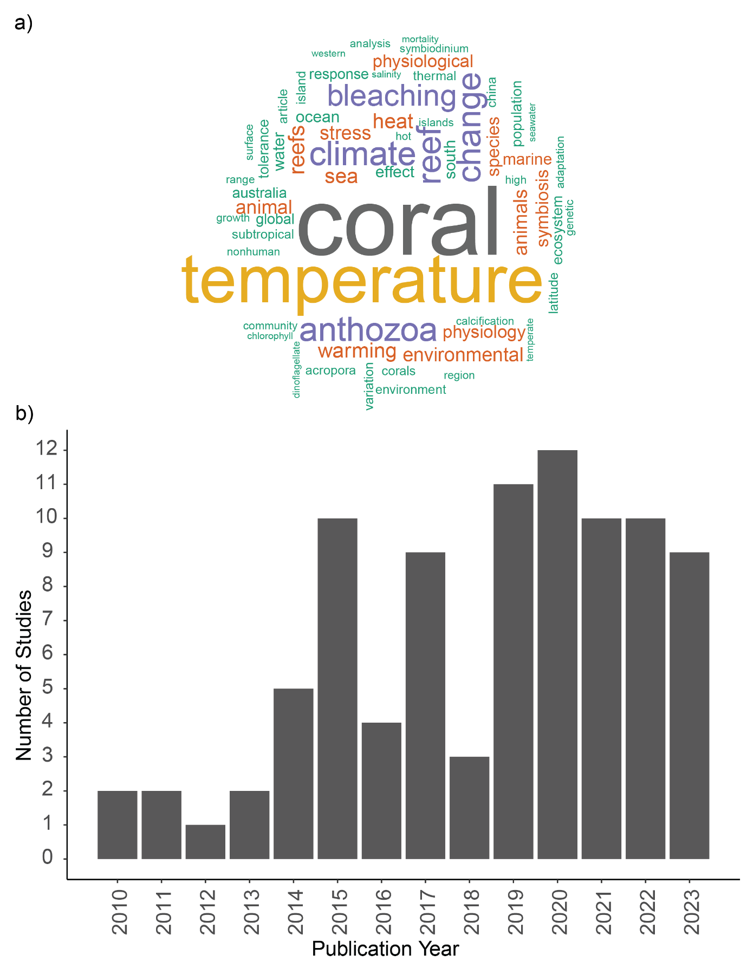

Figure 4 a) Word cloud featuring keywords appearing at least 10 times from the literature included in this systematic map. b) The number of publications by year. Note that this data is up to June 2023, and publication number for 2023 may be higher at time of publication.